NOS Report

- Student: ISSAM AWAMLEH
- Company: JODDB (cyber shield)
- URN of NOS: TECIS600201
- Name of NOS: Identify cyber security threats and vulnerabilities

**Performance criteria of the NOS and how you applied it in your company **
(Explain and include evidence from your work)
P1 Identify the main cyber security threats posed to organizations to clearly demonstrate risk
-I found vulnerability and it was part of ethical hacking exercises in a server before make it officially work we provided a Pcap file and need to know what kind of commands the 2 parties ( the client and the server ) request and response.
- the Manager gives us access to a machine called ( Y0uS3f ) has vulnerabilities hosted in the server.
the PT report can meet this by:
- The first task was network monitoring and it’s include using unsafe transmit protocols the packets are exposed and it’s plaintext.
- The second task was whole ethical hacking steps start with information gathering until getting to post exploitation. ( VSFTPD VULERABILITY AND SMB). (That was after access the machine )
- This Pt exercise is to establish the concepts of PT in mind’s by getting practical exercises of Network monitoring and weak encryption with additional topics like go through the PT steps and getting practical experience
- Demonstrating risk by stating:
  - Using unsafe protocols (FTP) → getting the credentials or critical information → Impersonation
  - Machine has SMB and VSFTPD vulnerability → exploiting the vulnerability → getting shell and RCE.
Threat Identification:
I would be providing the evidence for threat Identification.
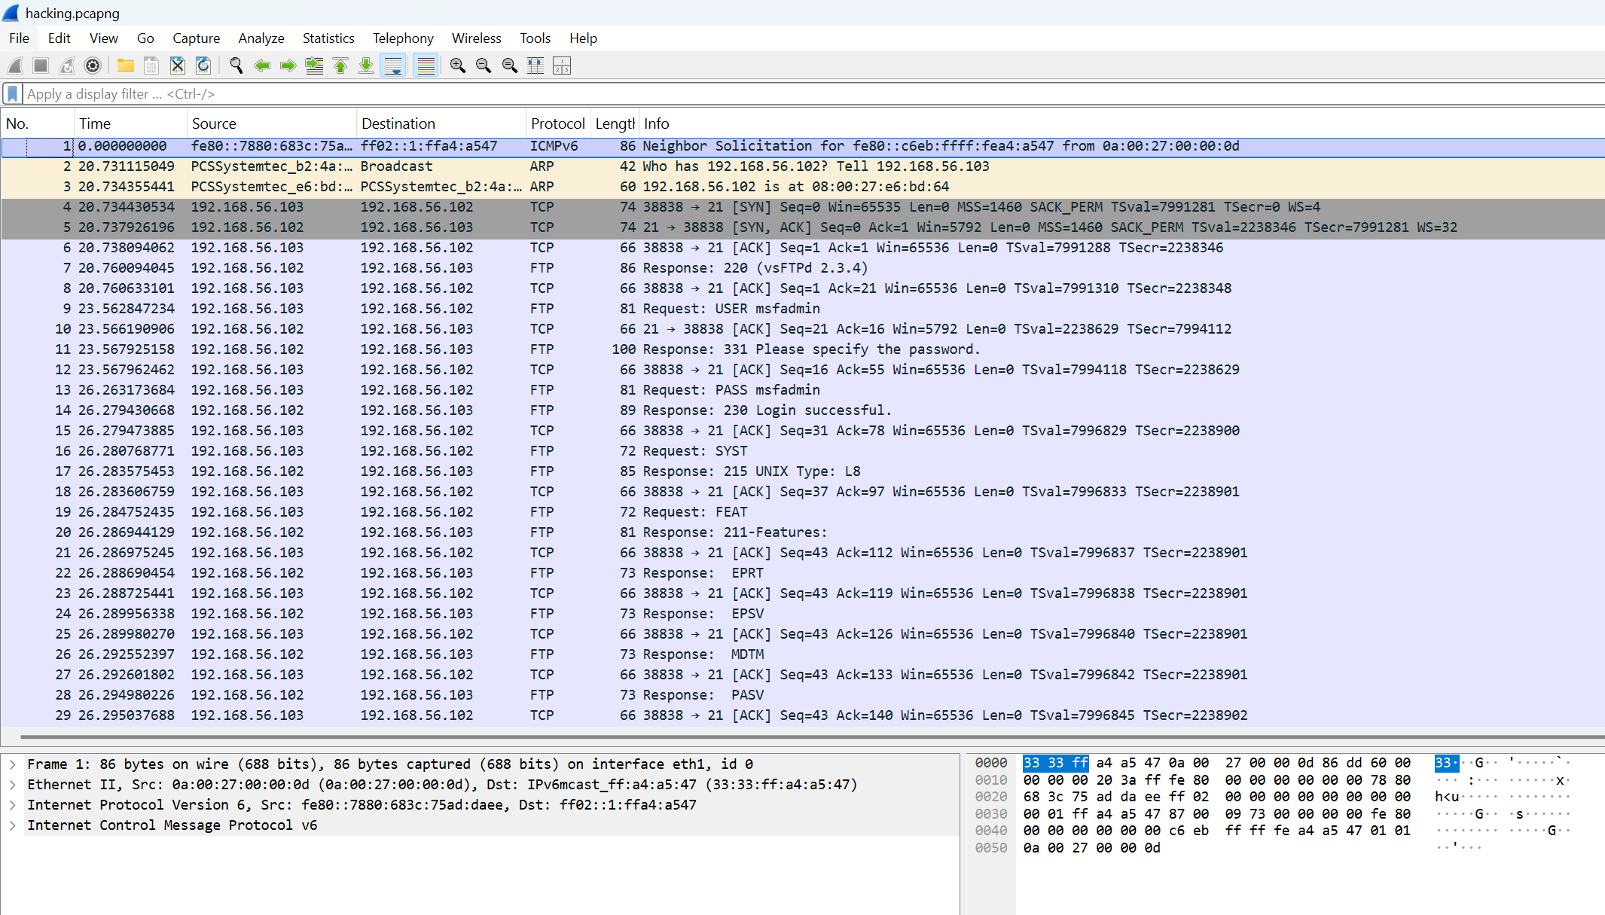
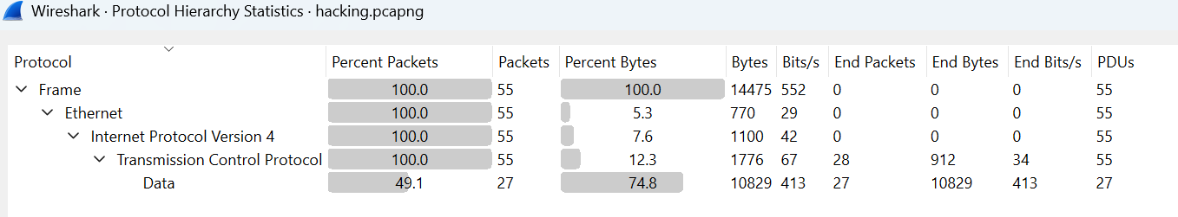
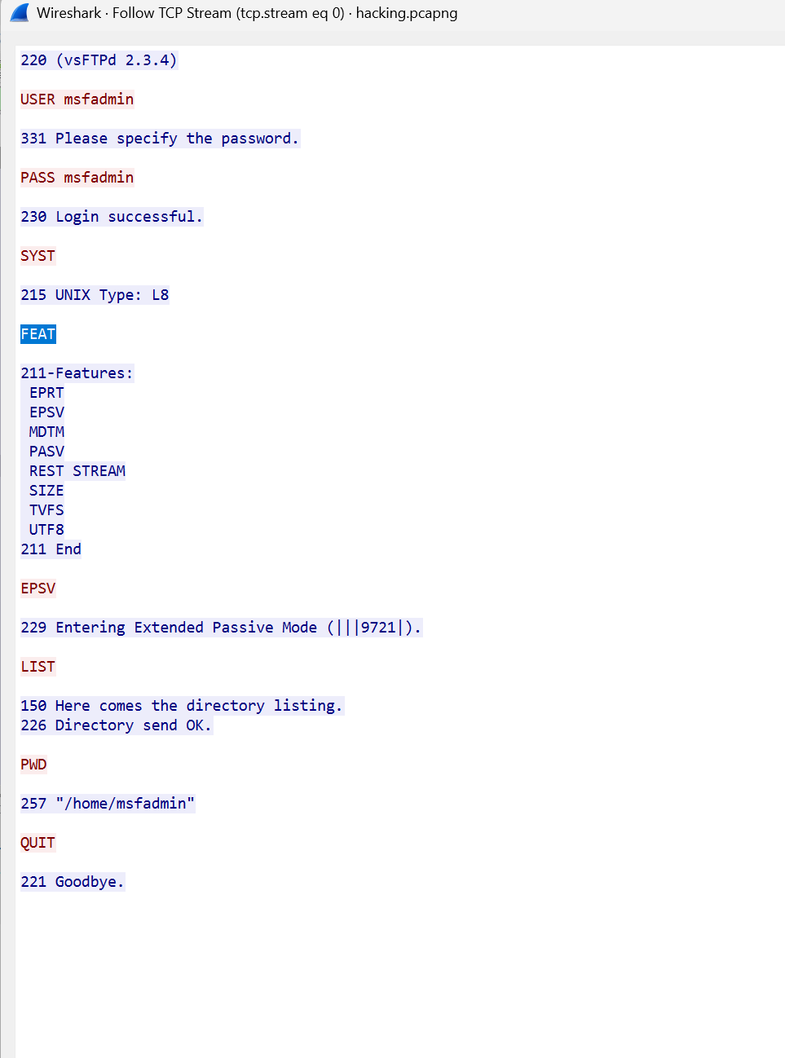

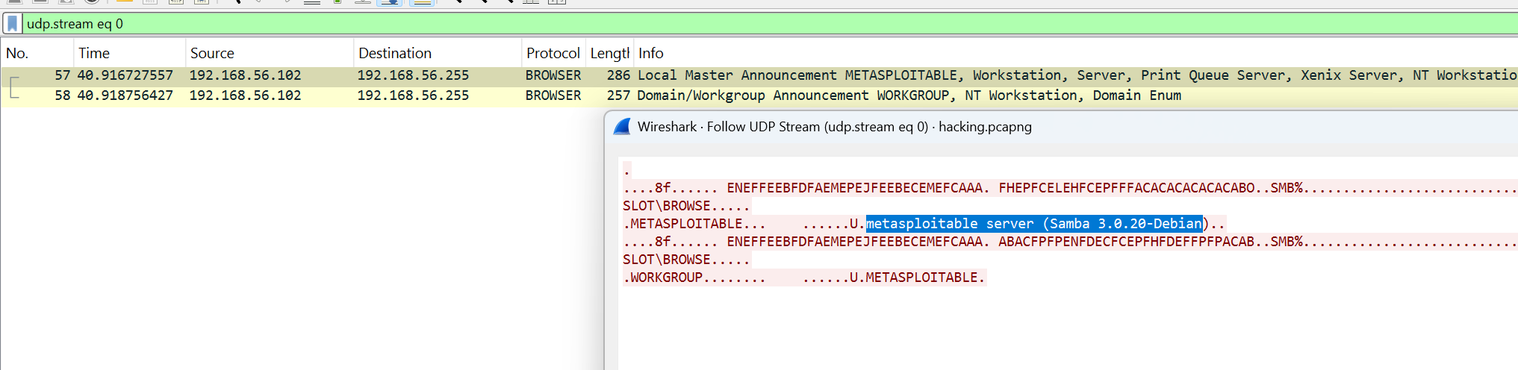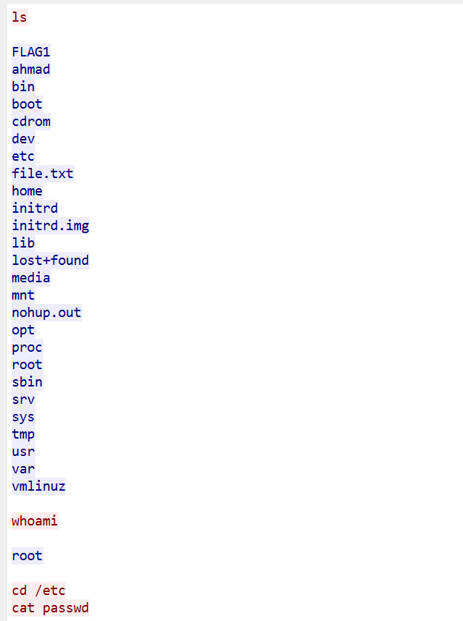
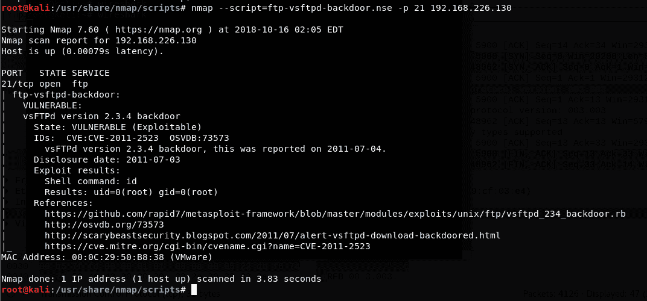
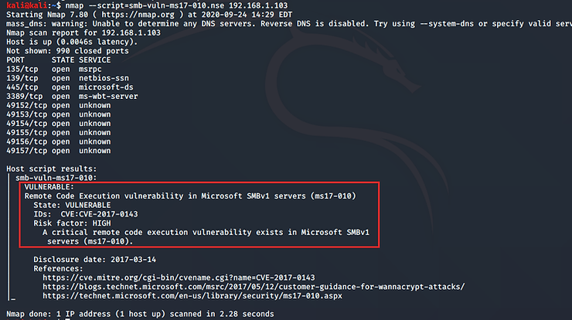
P2 : Evaluate the potential business risk of different cyber security threats to confidentiality, integrity, availability (CIA)
Weak encryption:
- Confidentiality: the attacker can easily see the information by doing simple enumeration steps on that server
- Integrity: By MITM attacks can easily tampering the packets the traffic was unencrypted so any attacker can see it
- Availability: it can impact the whole system in consideration that this server is part of it, that will make the system collapse
Example:
- Getting to unauthorized data→ confidentiality
- 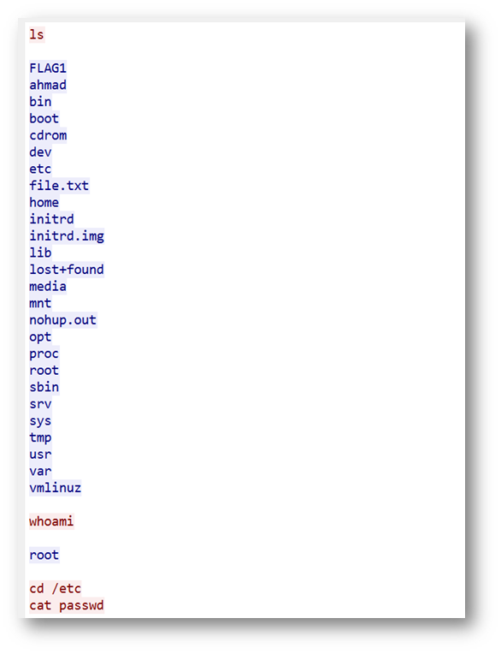
- Tampering the data → integrity
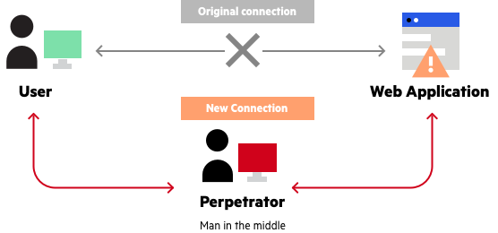
P3: Classify the common vulnerabilities that occur in networks, devices, and systems
1_ for the Network using FTP which is not secure protocol and we saw that the attacker seems using the vulnerability of VSFTPD, here’s some information about VSFTPD:
Description: This signature detects attempts to trigger a backdoor in compromised source packages of vsftpd.
Additional Information: vsftpd is prone to a backdoor vulnerability because the 'vsftpd-2.3.4.tar.gz' source package file contains a backdoor. An attacker can cause the application to open a backdoor on port 6200 by logging to the FTP server with the username ':)'.
2_ the attacker found In a machine 2 vulnerability which is the SMB (Samba) and VSFTPD.
Here’s some info about Samba vulnerability:This module exploits a command execution vulnerability in Samba versions 3.0.20 through 3.0.25rc3 when using the non-default
"username map script" configuration option. By specifying a username
containing shell meta characters, attackers can execute arbitrary
commands.
P4: Identify different forms of social engineering and respond appropriately.
Social Engineering Attacks: A Practical Guide
What is Social Engineering?
Social engineering is basically psychological manipulation. Instead of hacking computers, attackers hack people. They exploit our natural instincts like trust, curiosity, fear, and the desire to be helpful. Think of it as the digital equivalent of a con artist's tricks.

Common Attack Types
Phishing
You've probably seen these before—fake emails pretending to be from your bank, IT department, or a delivery service. They want you to click a malicious link or download something dangerous.
What it looks like: "Your account has been compromised! Click here immediately to secure it!"
Red flags: Urgent language, suspicious sender addresses, generic greetings like "Dear Customer"
Vishing (Voice Phishing)
This is phishing over the phone. Someone calls pretending to be from IT support, your bank, or even your boss's office.
What it sounds like: "Hi, this is Mike from IT. We detected suspicious activity on your account. Can you verify your password for me?"
Red flags: Unexpected calls asking for credentials, pressure to act quickly, caller ID can be faked
Pretexting
The attacker creates a whole fake scenario to gain your trust. They might spend days building a relationship before asking for what they really want.
Example: Someone poses as a new contractor, chats with employees for a week, then casually asks for system access to "finish their work."
Tailgating
This is when someone follows you through a secure door without using their own badge. They're counting on you being polite and holding the door.
Example: Someone carrying boxes waits by the entrance. When you badge in, they smile and walk in behind you. You hold the door because it seems rude not to.

Baiting: The USB Trojan Threat (Our Focus)( the high probability happened)
What Makes USB Attacks So Dangerous?
Imagine finding a USB drive in the parking lot labeled "Executive Salaries 2025" or "Confidential - Q4 Budget." Your curiosity kicks in. You plug it into your work computer "just to see what's on it." That's exactly what attackers count on.
Here's what happens:
- The Setup: Attacker loads a USB drive with malware
- The Drop: USB is left in parking lots, bathrooms, conference rooms, or mailed as "promotional gift"
- The Bite: You plug it in out of curiosity or helpfulness (trying to find the owner)
- The Infection: Malware installs automatically or when you open files
- The Damage: Attacker steals data, encrypts files (ransomware), or gains remote access
Why Does This Work So Well?
Human psychology: Studies show 45-98% of people plug in USB drives they find. We're curious creatures, and a physical device feels less threatening than clicking a sketchy email link.
It bypasses the security: While the company probably has email filters and firewalls, a USB drive walks right past all of that. It can even infect systems that aren't connected to the internet (called "air-gapped" systems).
Real-World Impact
Stuxnet: One of the most famous cyber weapons ever, believed to have spread partly through infected USB drives. It physically damaged Iranian nuclear centrifuges.
Corporate tests: Security researchers have dropped USB drives in company parking lots and watched as employees plugged in nearly every single one within hours.
Types of USB Attacks
The Simple One: USB contains files that look innocent (like "2025_Budget.xlsx") but actually contain malware.
The Sneaky One: USB Rubber Ducky—looks like a normal USB drive but acts like a keyboard, typing malicious commands faster than you can blink.
The Hidden One: USB shows normal files when you plug it in, but has a hidden partition with malware that installs in the background.

How the Organization Should Respond
Verification is Everything
The golden rule: When something feels off, it probably is. Always verify before acting.
For suspicious emails:
- Don't click links—type the website address directly into your browser
- Call the person using a number you look up yourself (not one from the email)
- Check the actual email address, not just the display name
- When in doubt, forward it to your IT security team
For phone requests:
- Hang up and call back using the official company number
- IT will never ask for your password—ever
- Get a ticket number and verify it through your company's system
- Don't let urgency override common sense
For physical security:
- Don't hold doors for people you don't recognize
- Every person needs their own badge—no exceptions
- If someone "forgot their badge," send them to reception
- Report anyone wandering without a visitor badge
Multi-Factor Authentication (MFA)
Think of MFA as a backup lock on your door. Even if someone steals your password (the key), they still need your phone (the deadbolt) to get in.
How it protects you:
- Stolen passwords become nearly useless
- You get alerts if someone tries to access your account
- Stops most automated attacks cold
Common types:
- Text messages with codes (better than nothing)
- Authenticator apps like Google Authenticator (much better)
- Physical security keys (best option)
Reporting Procedures
If you receive a suspicious email:
- Don't click anything or download attachments
- Forward it to your security team (usually something like security@yourcompany.com)
- Delete the original
If you clicked something you shouldn't have:
- Disconnect from the network immediately (unplug ethernet or turn off WiFi)
- Call IT security right away—don't wait
- Don't turn off your computer (they might need to examine it)
- Write down what happened while it's fresh in your mind
If you find a suspicious USB drive:
- Don't plug it in—seriously, resist the urge
- Report it to security
- They'll handle it safely using isolated systems
Remember: Reporting quickly isn't about getting in trouble—it's about containing damage. The sooner security knows, the less harm the attack can do.

Social Engineering Risks
Why These Attacks Keep Working
We're wired to be helpful: Your instinct is to hold doors, answer questions, and assist people. Attackers exploit this basic human decency.
Authority is persuasive: When someone claims to be your boss, a police officer, or IT support, we tend to comply without questioning.
Curiosity is powerful: A USB labeled "Confidential" or an email about "Important Updates" triggers our need to know.
Fear drives action: "Your account will be closed!" or "Security breach detected!" makes us panic and act without thinking.
The Real Cost
Data breaches: Customer information, intellectual property, financial records—all stolen through a moment of trust.
Ransomware: One clicked link or plugged-in USB can encrypt your entire company's data, demanding payment to unlock it.
Reputation damage: Breaches make news headlines and customers lose trust.
Financial impact: Average cost of a data breach is $4.45 million, not counting legal fees and lost business.
Your Role in Security
You're not just a potential victim—you're a crucial part of your company's defense. Security tools can only do so much. The real protection comes from employees who:
- Question unusual requests
- Verify before acting
- Report suspicious activity
- Follow security policies even when they're inconvenient
Think of it this way: Attackers only need to trick one person once. Your vigilance protects not just yourself, but your colleagues, your company, and your customers.

Quick Reference: Red Flags
Stop and verify if you encounter:
- Unexpected urgency ("Act now or your account will be locked!")
- Requests for passwords or sensitive data
- USB drives or devices you didn't expect
- People without badges in secure areas
- Emails with suspicious links or attachments
- Phone calls asking you to verify account information
- Anything that just feels "off"
When in doubt: Report it. Better to report ten false alarms than to miss one real attack.

In my case we provided a link with chat boat to social engineering a victim to take some credentials by using (SET):
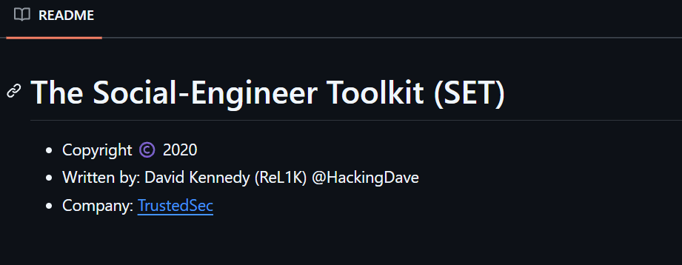
To cloning the chat boat to get the credentials .
P5: Work Safely and Securely at All Times
Authorized task Environment
All cybersecurity activities described in this report were conducted exclusively within JODDB (Cyber Shield)'s authorized training task environment. The exercises were part of a structured ethical hacking Task designed for practical and testing purposes under supervised conditions.
Rules of Engagement
I strictly adhered to the following rules of engagement:
Scope:
- Testing was limited to the designated vulnerable machines provided by the Manager (specifically the "Y0uS3f" machine and associated network captures)
- No unauthorized systems or networks were accessed
- All activities remained within the Task's isolated network environment
Time:
- Activities were conducted for 2 weeks work hours.
- All testing followed the Tasks timeline and deadlines set by Cyber Shield
Tools Allowed:
- You’re free to choose your tools to hack
Legal and Ethical Practices
- All penetration testing activities were performed with explicit authorization from Cyber Shield Manager
- • My role was to discover any potential security vulnerabilities, and I found them in the infected device.
- It was a kind of real-world systems were targeted
• Activities were conducted solely to understand vulnerabilities and defensive measures
Data Handling and Privacy
- No unauthorized data access: Only information within the scope of authorized lab machines was examined
- The PCAP file analysis was limited to understanding protocol vulnerabilities (FTP plaintext credentials)
- Any sensitive information discovered (credentials, system data) remained within the Task environment and was not shared externally
- Data was handled according to Cyber Shield's protocols
Responsible Tool Usage
- Exploitation tools (Metasploit for VSFTPD and SMB vulnerabilities) were used exclusively for authorized ethical testing
- Network monitoring tools (Wireshark) were used only on task traffic
- All tools were employed to demonstrate defensive concepts, not for malicious purposes
- Knowledge gained was applied toward understanding how to protect systems, not compromise them
Compliance and Documentation
- All activities were documented in this report for documentation assessment purposes
- Followed internal Cyber Shield policies and Tasks guidelines
- Respected the legal framework governing ethical hacking and penetration testing in Jordan
- Maintained confidentiality of task configurations and any discovered vulnerabilities outside the Task context
P6: Comply with Organisational Requirements Regarding Safe Online Behaviour
Safe Online Behaviour & Cyber Hygiene
Secure Testing Environment
All my work at Cyber Shield was done in a completely isolated Task environment. That was in internal network and resources like sandbox where we can safely "break things" without any risk to real systems. The Y0uS3f machine and network captures were contained within this closed network, so there was zero chance of accidentally affecting anything outside the Task.
Avoiding Risky Behaviours
During the course, I made sure to:
- Never click suspicious links: Even when analyzing phishing examples, I only examined them in controlled conditions, never on my personal devices
- No unauthorized downloads: to make it real world scenario and to play the role of the hacker so any tool was approved to be used.
- Cautious with networks: When working on Task , I used the secure Task network—not public WiFi where someone could intercept my traffic (ironic, considering we were learning about packet sniffing!)
- Clean browsing habits: Kept personal browsing separate from Task work, used different browsers/profiles to avoid any cross-contamination and using VMware to do the attack.
Following Best Practices
I treated the Task environment with the same care I'd use in a real workplace:
- Logged out of systems after each session
- Didn't share Task credentials or access with anyone outside the Project
- Kept my own devices updated and protected while doing the Task
- Used strong, unique passwords for Task access
Personal Reflection on Safe Behaviour
Here's what really stuck with me: learning how to exploit vulnerabilities made me way more careful in my own online life. When you see how easy it is to capture FTP credentials in plaintext or how quickly someone can exploit an unpatched system, you start taking security seriously.
Now I:
- Think twice before plugging in any USB drive (even my own—who knows what I might have picked up?)
- Actually read URLs before clicking (no more auto-pilot clicking!)
- Enable MFA everywhere I can
- Keep my systems patched and updated
The biggest lesson? Security isn't just technical—it's behavioral. You can have the best firewalls and antivirus in the world, but if someone clicks the wrong link or uses "Password123," none of it matters. That's why following safe online practices isn't just about compliance—it's about protecting yourself, your colleagues, and your organization from real threats.

